**Operating System Lab**

**CS342**

Tanishq Malu Lab:5 1901CS63

Q1 The main thread creates ten threads. Then it waits for the threads to terminate, printing the status returned by each thread. The last thread was cancelled which is recorded in the output. Write a C program for this behaviour.

Compilation:

g++ -o q1 q1.c -lm -pthread -fopenmp

Syntax:

./q1

Sample Input and Output:

Input:

g++ -o q1 q1.c -lm -pthread -fopenmp

./q1

Output:

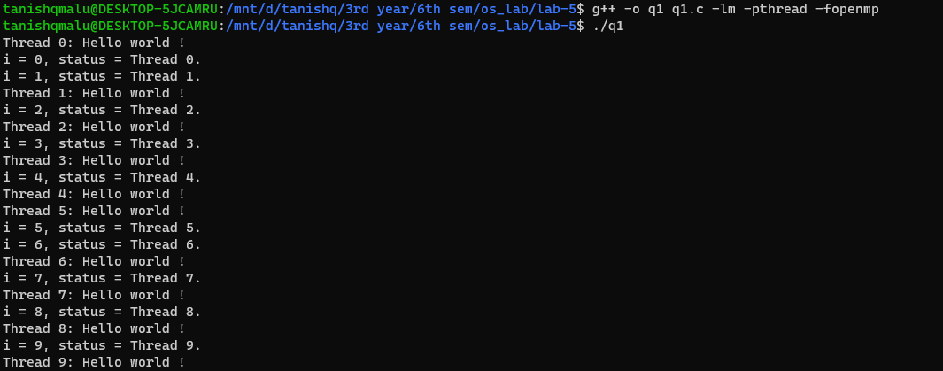

Q 2. Write a C program using two threads to write a text file where first thread writes all the lines except prime numbered lines and second thread writes all the prime numbered lines. The third thread should parallelly count the number of characters being written in each line of the file.

Compilation:

g++ -o q2 q2.c -lm -pthread -fopenmp

Syntax:

./q2 filename1 filename2

Sample Input and Output:

Input:

g++ -o q2 q2.c -lm -pthread -fopenmp

./q2 t1.txt t2.txt

Output: 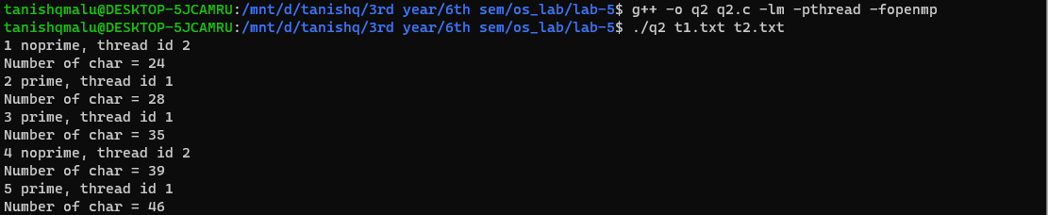

Input:

g++ -o q2 q2.c -lm -pthread -fopenmp

./q2 p1.txt p2.txt

Output:

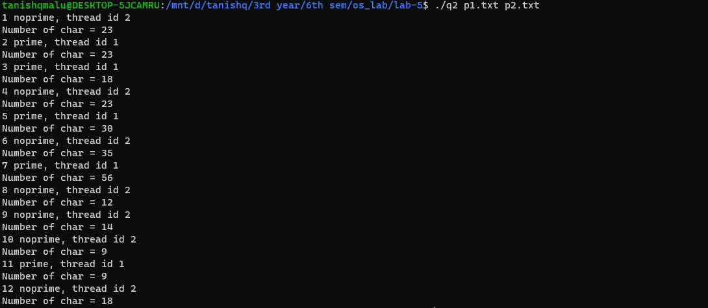

Q3 There are “M” vending machines linked to single petrol tanker with capacity of “L” litres. “ni, where 0<i<=M” number of customers are coming to each machine in “M” different queues to take some petrol in parallel manner. The vending machine should dispense only if the required amount of petrol is available in the tanker. And after dispensing to each customer the amount of petrol present in the tanker should be updated. Write a C program using thread for the petrol dispensing system.

Compilation:

g++ -o q3 q3.c -lm -pthread -fopenmp

Syntax:

./q3

Input format:

Petrol --- Total petrol available

M --- Number of petrol junction

N1 --- Number of customers in first junction

A1,A2……. $A_{N_{1}}$--- Ai denotes the amount of petrol each person wants to fill

N2

A1,A2……. $A_{N_{2}}$

N3

A1,A2……. $A_{N_{3}}$

.

.

.

Instead of taking command in terminal, simply read an input file. To use different inputs, comment out other input file except the file from where input needs to be read.

$$N_{M}$$

A1,A2……. $A_{N_{M}}$

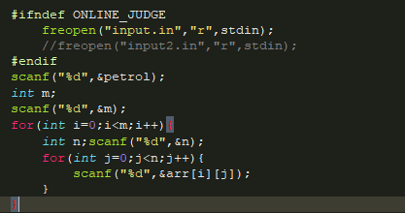

Sample Input and Output:

Input:

Input.in

Output:

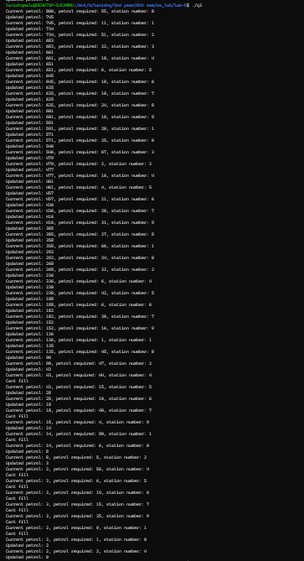

Current petrol: 800, petrol required: 55, station number: 0

Updated petrol: 416

Current petrol: 416, petrol required: 31, station number: 9

Updated petrol: 385

Current petrol: 385, petrol required: 27, station number: 8

Updated petrol: 358

Current petrol: 358, petrol required: 66, station number: 1

Updated petrol: 292

Current petrol: 292, petrol required: 24, station number: 0

Updated petrol: 268

Current petrol: 268, petrol required: 32, station number: 2

Updated petrol: 236

Current petrol: 236, petrol required: 6, station number: 4

Updated petrol: 230

Current petrol: 230, petrol required: 42, station number: 5

Updated petrol: 188

Current petrol: 188, petrol required: 6, station number: 6

Updated petrol: 182

Current petrol: 182, petrol required: 30, station number: 7

Updated petrol: 152

Current petrol: 152, petrol required: 16, station number: 9

Updated petrol: 136

Current petrol: 136, petrol required: 1, station number: 1

Updated petrol: 135

Current petrol: 135, petrol required: 45, station number: 0

Updated petrol: 90

Current petrol: 90, petrol required: 47, station number: 2

Updated petrol: 43

Current petrol: 43, petrol required: 44, station number: 4

Cant fill

Current petrol: 43, petrol required: 15, station number: 5

Updated petrol: 28

Current petrol: 28, petrol required: 10, station number: 6

Updated petrol: 18

Current petrol: 18, petrol required: 40, station number: 7

Cant fill

Updated petrol: 745

Current petrol: 745, petrol required: 11, station number: 1

Updated petrol: 734

Current petrol: 734, petrol required: 51, station number: 2

Updated petrol: 683

Current petrol: 683, petrol required: 22, station number: 3

Updated petrol: 661

Current petrol: 661, petrol required: 10, station number: 4

Updated petrol: 651

Current petrol: 651, petrol required: 6, station number: 5

Updated petrol: 645

Current petrol: 645, petrol required: 10, station number: 6

Updated petrol: 635

Current petrol: 635, petrol required: 10, station number: 7

Updated petrol: 625

Current petrol: 625, petrol required: 24, station number: 8

Updated petrol: 601

Current petrol: 601, petrol required: 10, station number: 9

Updated petrol: 591

Current petrol: 591, petrol required: 20, station number: 1

Updated petrol: 571

Current petrol: 571, petrol required: 25, station number: 0

Updated petrol: 546

Current petrol: 546, petrol required: 67, station number: 3

Updated petrol: 479

Current petrol: 479, petrol required: 2, station number: 2

Updated petrol: 477

Current petrol: 477, petrol required: 16, station number: 4

Updated petrol: 461

Current petrol: 461, petrol required: 4, station number: 5

Updated petrol: 457

Current petrol: 457, petrol required: 21, station number: 6

Updated petrol: 436

Current petrol: 436, petrol required: 20, station number: 7

Current petrol: 18, petrol required: 4, station number: 9

Updated petrol: 14

Current petrol: 14, petrol required: 90, station number: 1

Cant fill

Current petrol: 14, petrol required: 6, station number: 0

Updated petrol: 8

Current petrol: 8, petrol required: 5, station number: 2

Updated petrol: 3

Current petrol: 3, petrol required: 56, station number: 4

Cant fill

Current petrol: 3, petrol required: 6, station number: 5

Cant fill

Current petrol: 3, petrol required: 19, station number: 6

Cant fill

Current petrol: 3, petrol required: 15, station number: 7

Cant fill

Current petrol: 3, petrol required: 35, station number: 9

Cant fill

Current petrol: 3, petrol required: 9, station number: 1

Cant fill

Current petrol: 3, petrol required: 1, station number: 0

Updated petrol: 2

Current petrol: 2, petrol required: 2, station number: 4

Updated petrol: 0

(P.T.O)

Input:

Input2.in

Output:

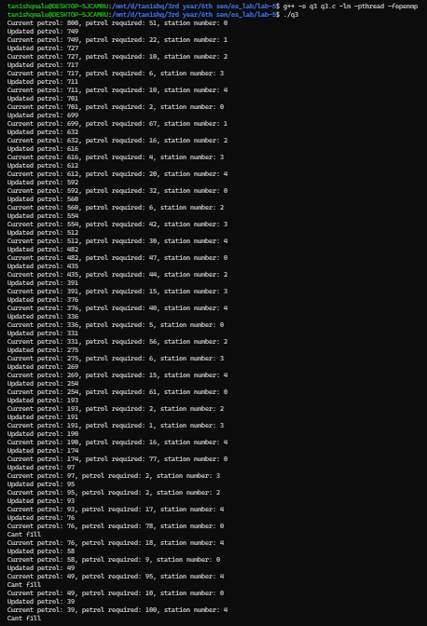

-------------------------------------------------- The End -----------------------------------------------